**Flooding Risk Assessment**

**Introduction/Review:**

The flooding risk has traditionally been evaluated by the FEMA flooding zone. The creation of the flooding zone was mandated under the National Flooding Insurance Program originated from the National Flood Insurance Program Act of 1968 (Brown, 2016). The first sets of maps were created through the Flood Hazard Study (FHS), which consists of compiling geophysical and environmental data, conducting land and aerial surveys, and interviewing local citizens. The flooding zone map was then improved and digitized under the Map Modernization program between 2003 and 2008 for approximately $1B in federal funds (Morrissey, 2006; Maidment, 2009). The FEMA flooding zone, however, is based on historical flooding and meteorological records so that it does not account for future flooding risk.

In addition, there is extensive literature on flooding risk assessments or flood inundation models (e.g., Teng et al., 2017; Mignot and Dewals, 2019). In general, there are two groups of methods; empirical data-driven models and physically-based hydrodynamic models. The empirical methods are based on historical records of flooding extents and river stage measurements and remote sensing-based inundation areas (Smith et al., 1997) as well as various statistical/machine learning methods models (e.g., Darabi et al., 2019). The physically-based models are based on either one-dimensional river-routing/channel-flow models or two-dimensional shallow-water equations (depth-averaged Navier-Stokes equations) for representing the water depth at a given location (Teng et al., 2017). These models require a digital elevation model and meteorological inputs, and they are solved by numerical methods.

The [First Street Foundation Flood Model](https://floodfactor.com/methodology) is a nationwide, probabilistic flood model that shows any location’s risk of flooding from rain, rivers, tides, and storm surge. The model is built on a recently developed hydraulic model, FASOM, which has been validated by the past flooding events (e.g., Sampson et al., 2015; Wing et al., 2017). Traditionally, the flooding risk analysis was local-scale and/or based on historical occurrences. FASOM employs a coupled data-driven and physical-based model to simulate flooding at the continental scale, by taking advantage of recent advances in computing capabilities as well as variability of topography and other spatial data layers. The model incorporates the USGS National Elevation Dataset, and the U.S. Army Corps of Engineers (USACE) National Levee Database (NLD) to represent known flood defenses.

The model first estimates extreme discharge based on the regionalized flood frequency analysis of Smith et al. (2015) as well as clustering approaches to classify catchments based on climate zone, catchment area, and upstream annual rainfall so that the datasets so that flood frequencies are transferred from gauged catchments to ungauged ones. The mode alsol includes a physically-based hydraulic model ISFLOOD-FP, which solves the shallow water equations (i.e., kinematic wave equations) in 2D (Neal et al., 2012). To improve the accuracy, it incorporates the subgrid representation of river channels, the width of which can be smaller than the grid size. In addition to fluvial flooding, the model incorporates pluvial flooding for simulating flood hazard in small headwater channels. Since flooding is typically flashy and driven by intense local rainfall events, the pluvial model uses rainfall scenarios derived from the Intensity-Duration-Frequency (IDF) relationships from the National Oceanic and Atmospheric Administration (NOAA).

For the future prediction, the model incorporates the output of an ensemble of 21 Global Climate Models (GCM) under the RCP4.5 scenario to account for the future precipitation as well as their uncertainty. The resulting high, median, and low environmental scenarios are then used as inputs for the flooding model. The model outputs are the extent and depth of flooding given selected probabilities (0.2%, 1%, 10%, 20%, 50%) in 15 or 30 years in the future.

**Method:**

We used the national-wide First Street Foundation Flood Model results from floodfactor.com. We mapped the flooding extent with the likelihood of 1% in the next 30 years. We performed this analysis at 21 sites at which flooding was identified as a concern in the site manager survey. Since the website does not provide the shape file, we evaluated the flooding extent by comparing two images: (1) the site boundary from the GEMS database and (2) the flooding extent. Note that the results are available for the lower 48 states; we did not have the data for the Amchitka (AK) and Bonus (PR) sites.

**Results:**

The example images (Figure X1) show that, at the Canonsburg site (PA), there is a potential flooding extent in the northern part of the site, including some extent of the disposal cell. It is because the site is located in the meandering region of the Chartiers Creek; three sides of the boundary are surrounded by the river.

Of the 19 sites evaluated (Table 1), none of the sites are fully covered by the 1%-probability flooding extent. At the 4 sites (Bluewater, Canonsburg, Rifle, Sharwood), there is some area impacted by the flooding zone (Figure X2 for the Rifle site as an example). At the 8 sites (L-Bar, Burrell, Mound, Monticello, Monument Valley, Rocky Flats, Slick Rock), the flooding zone is limited to the drainage features (Figure X3 for the Rocky Flat site as an example). All the images are shown in the Appendix X.

However, we have noticed that the Riverton site does not overlap with the flooding zone (even at the 0.2% likelihood or 500-year flood), despite the fact that flooding has been observed multiple times. There can be multiple reasons for this: (1) the snowmelt-induced flooding is not well captured, (2) the digital elevation model is not accurate enough to represent the small elevation difference typically found in the extensively meandering flat floodplain regions, (3) the site is located near the confluence of two rivers where the model has to account the impact from two rivers, and (4) the model is not extensively validated in rural regions of the western US (as opposed to the southeastern US where extensive flooding studies have been conducted).

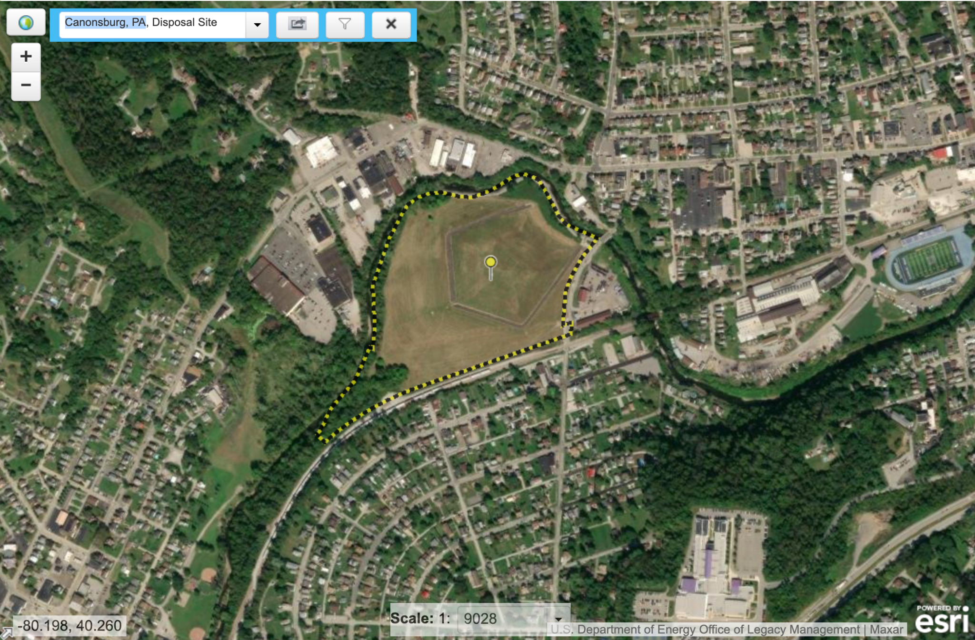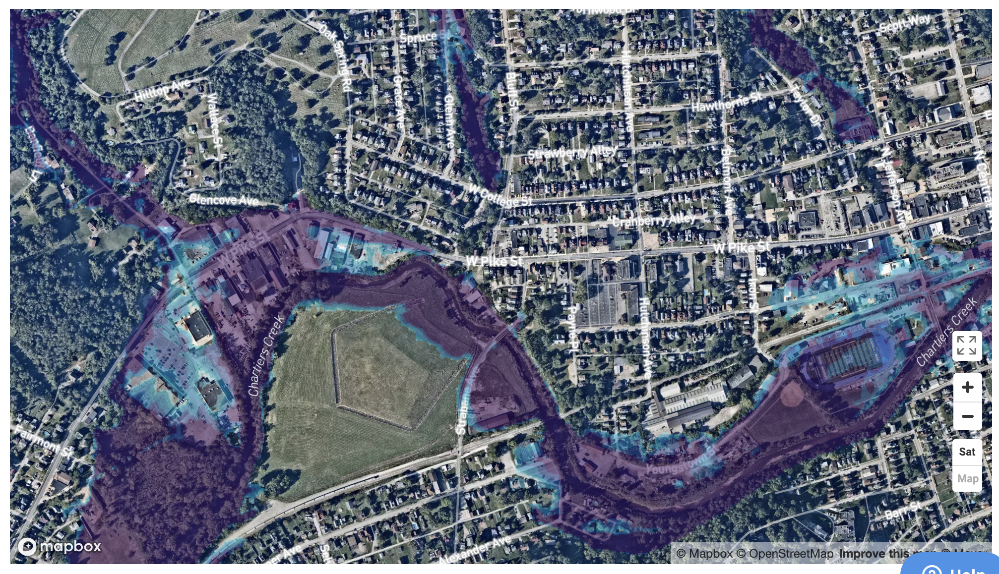

(a) (b)

Figure X1. Cannonsburg (PA): (a) the site boundary from the GEMS database and (b) the flooding extent from the First Street Foundation Flood Model. In (b), the light blue area is the flooding extent up to the depth of 1 meter, while the purple area is the one of larger than 1 meter.

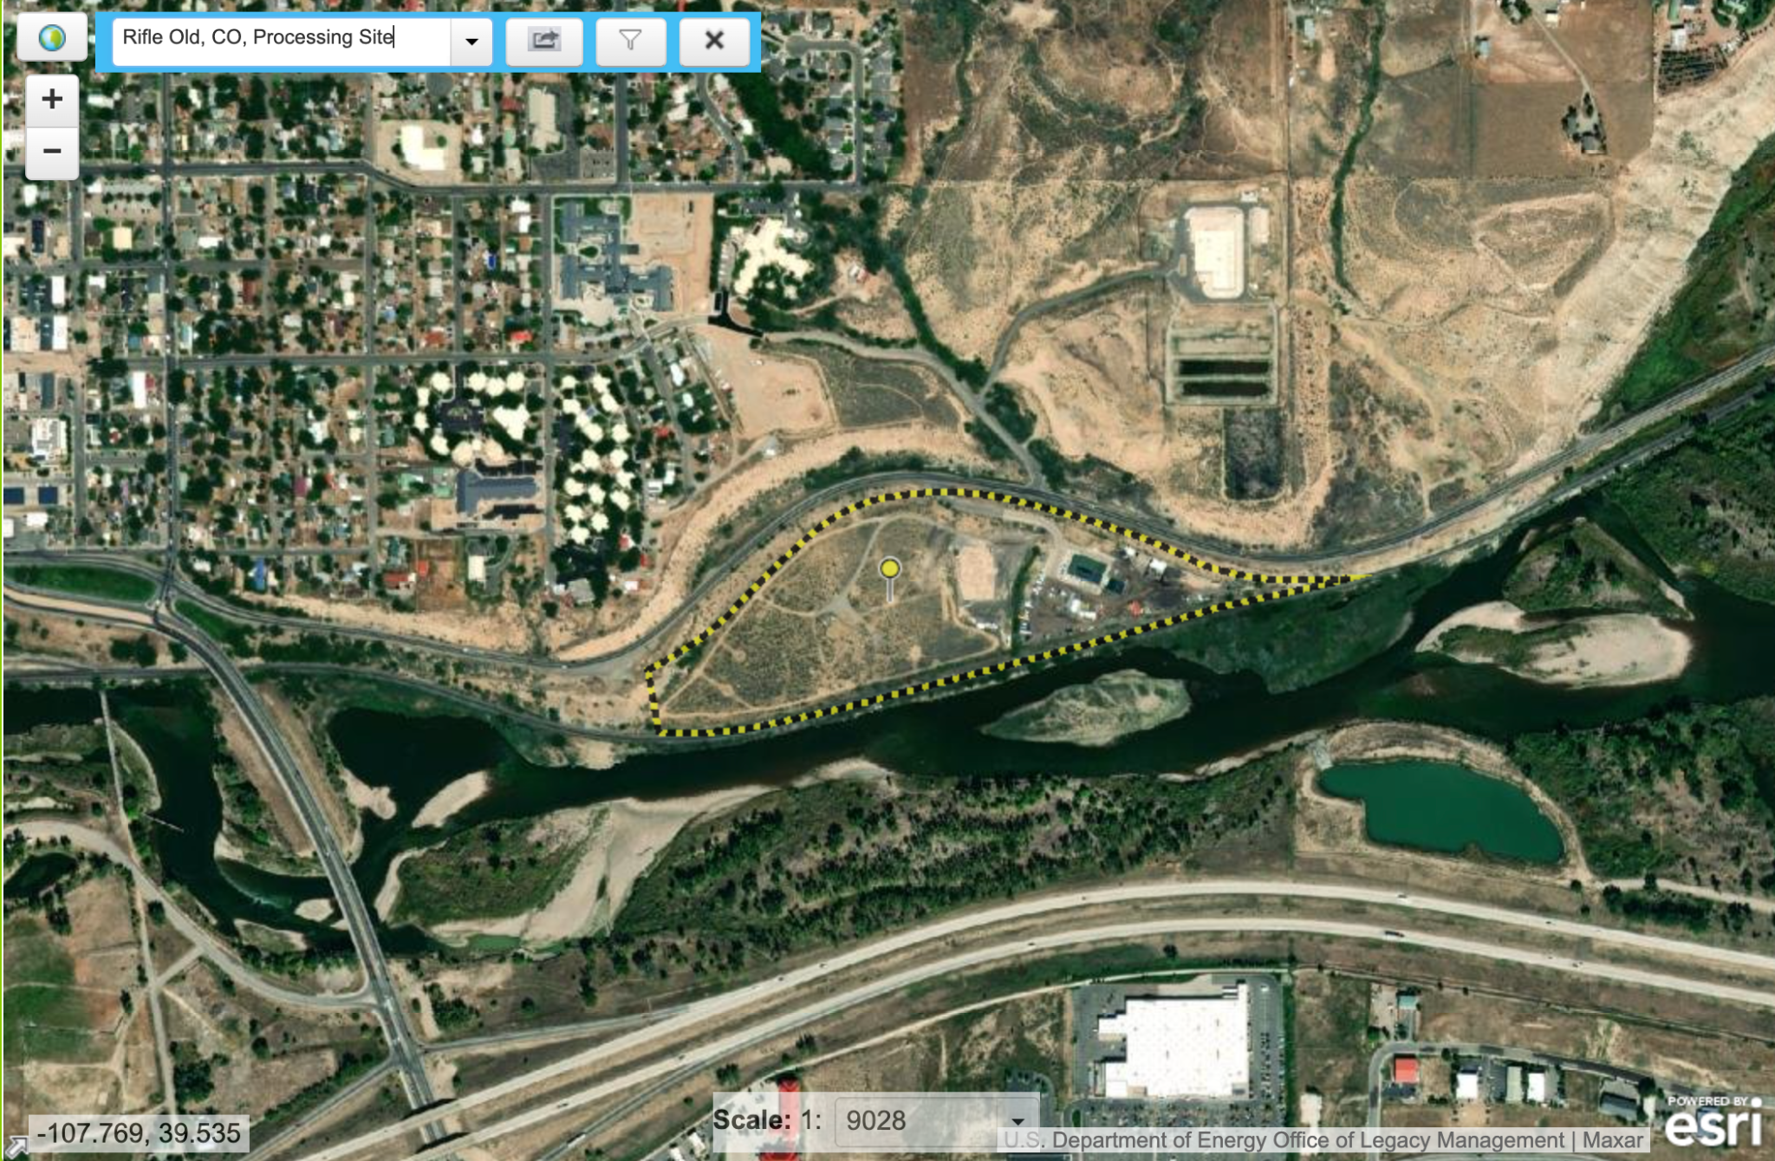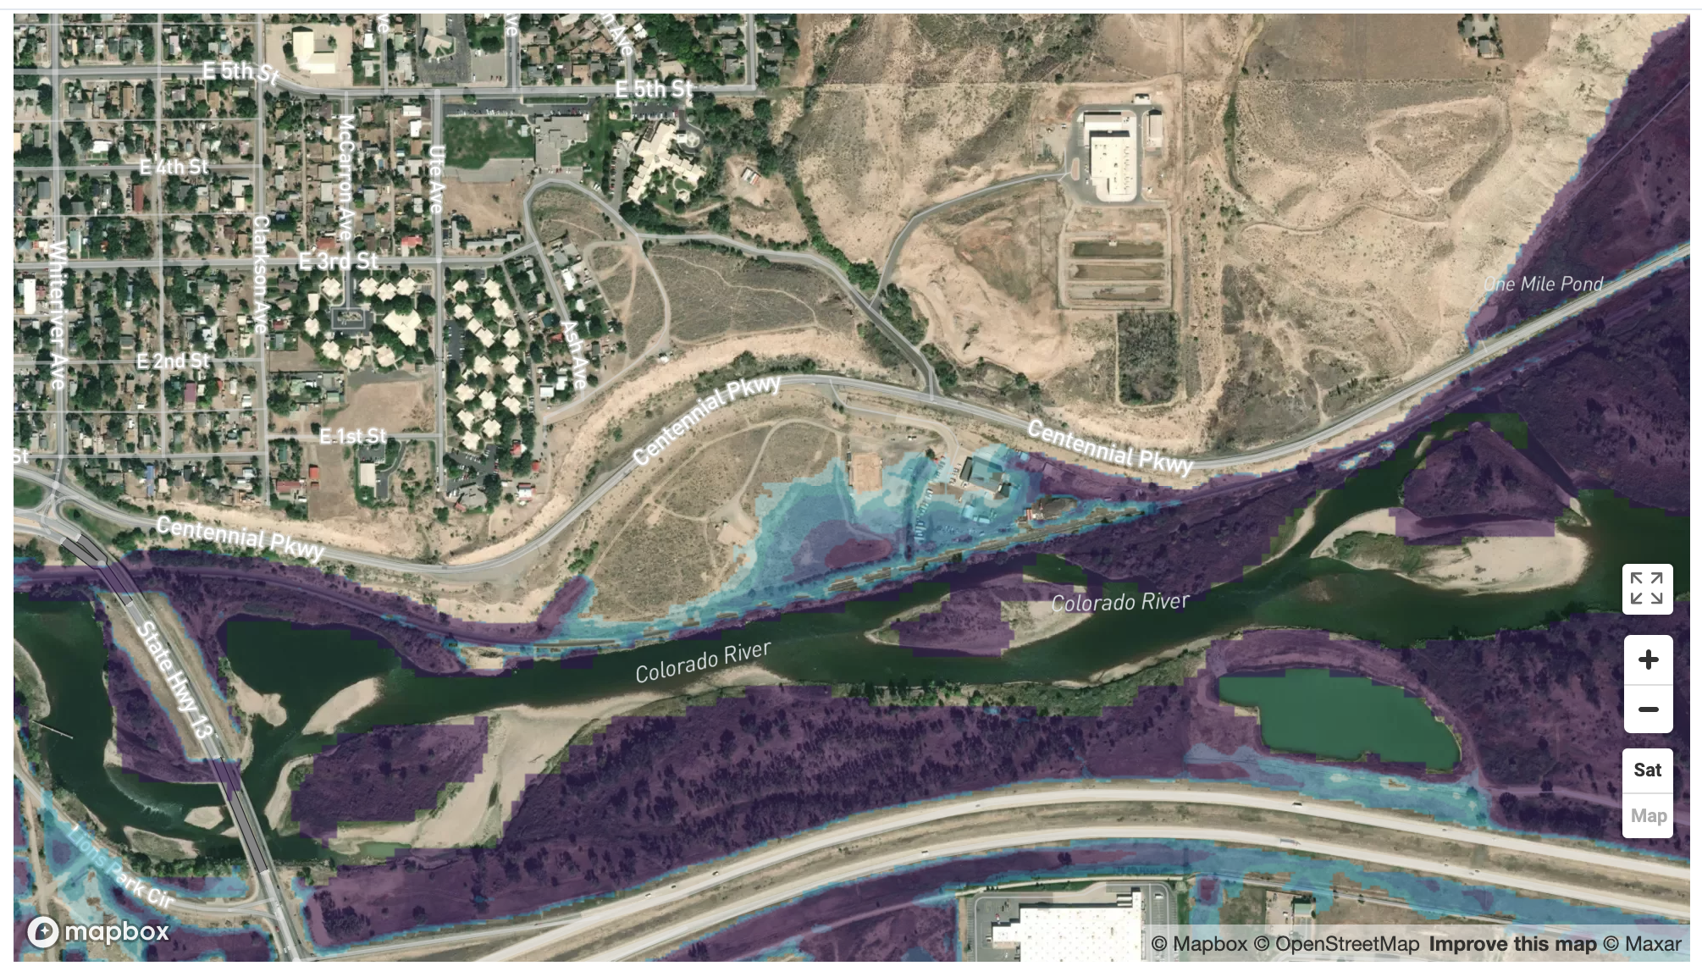

(a) (b)

Figure X2. Old Rifle (CO): (a) the site boundary from the GEMS database and (b) the flooding extent from the First Street Foundation Flood Model.

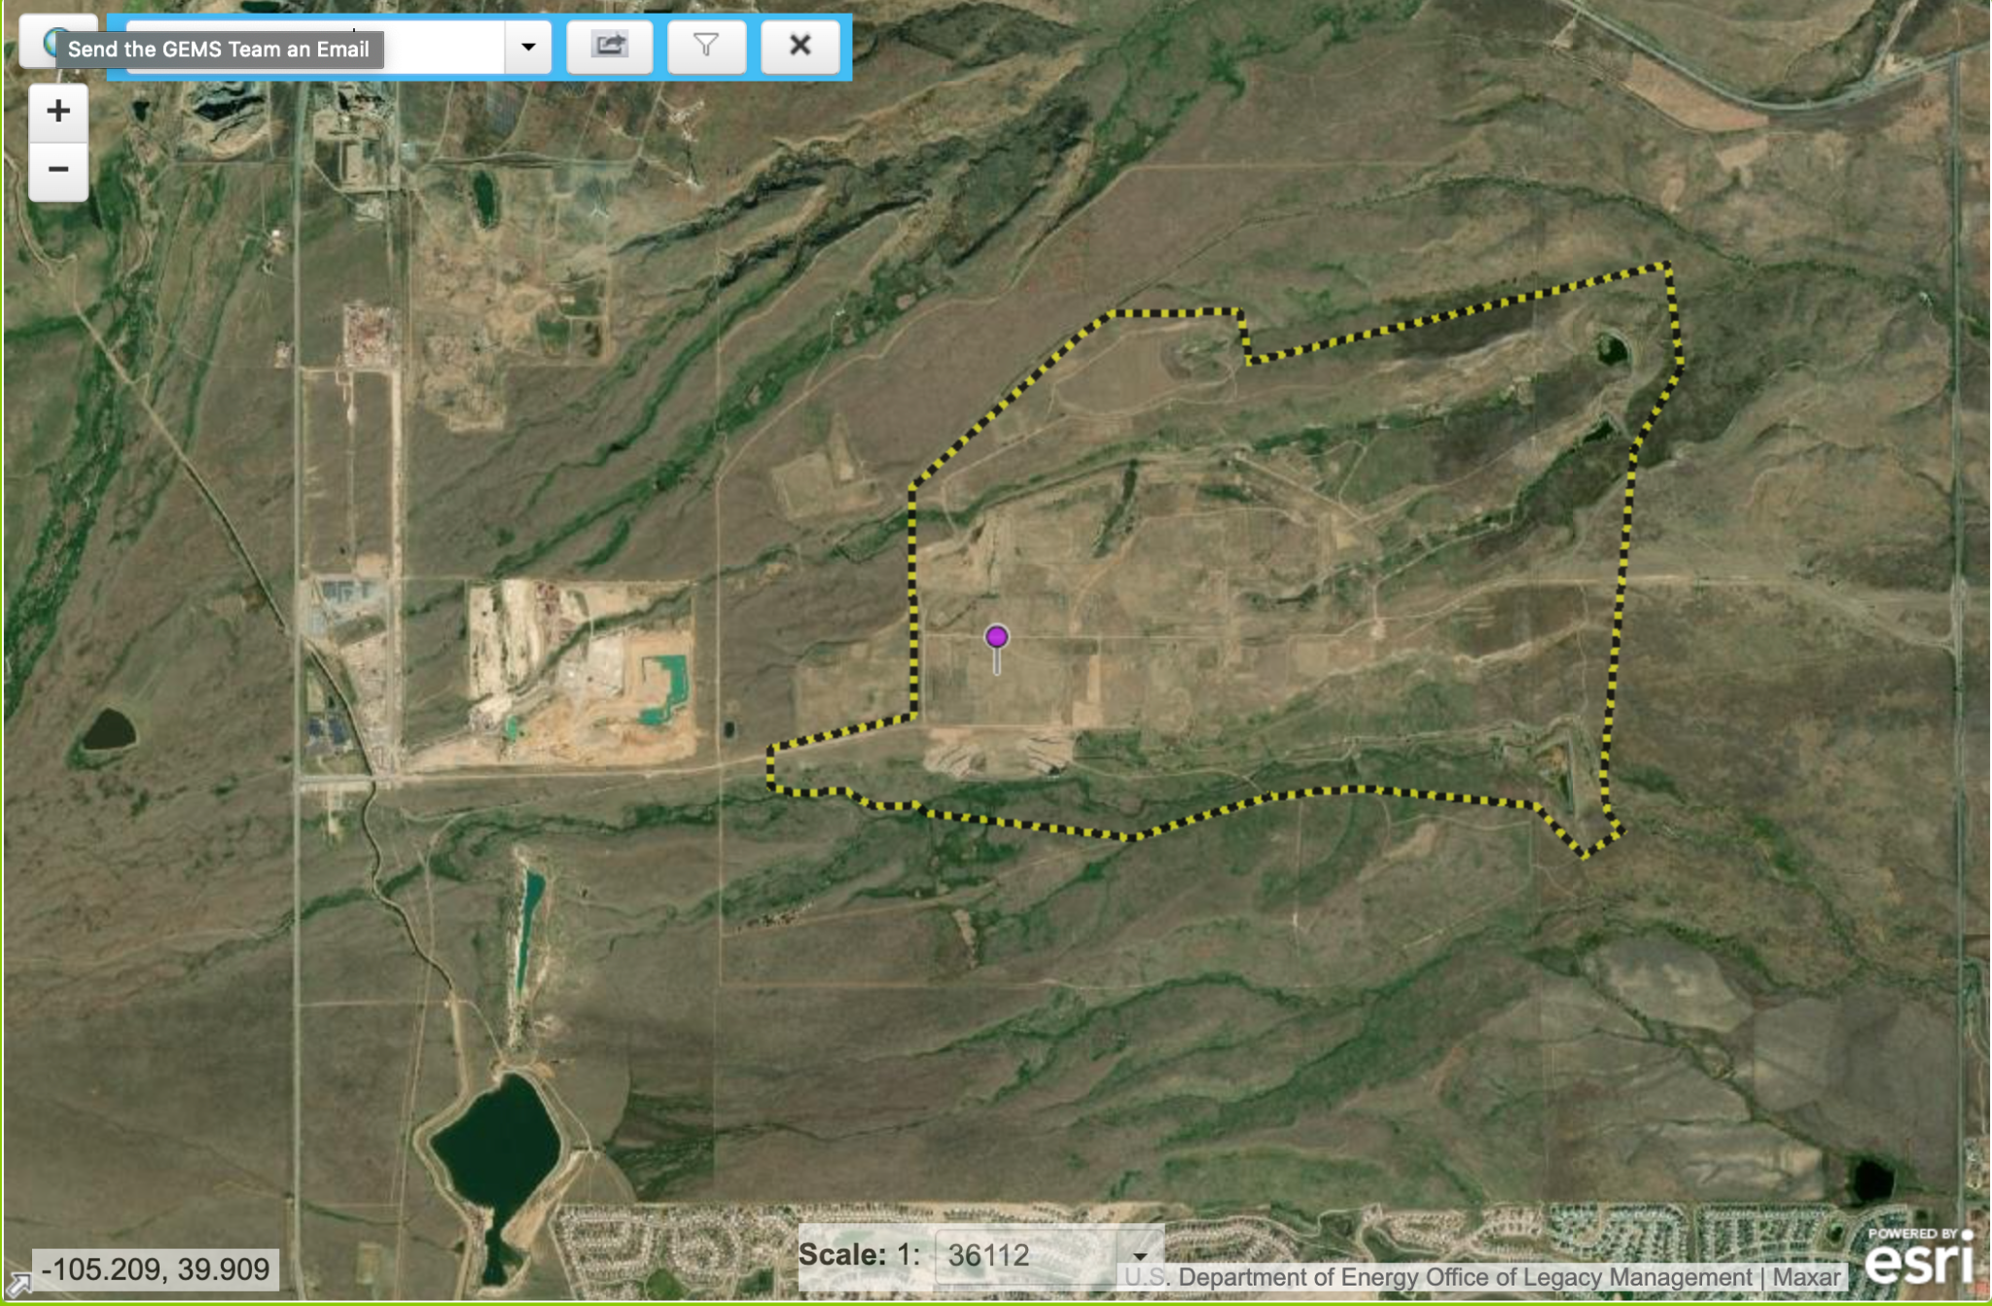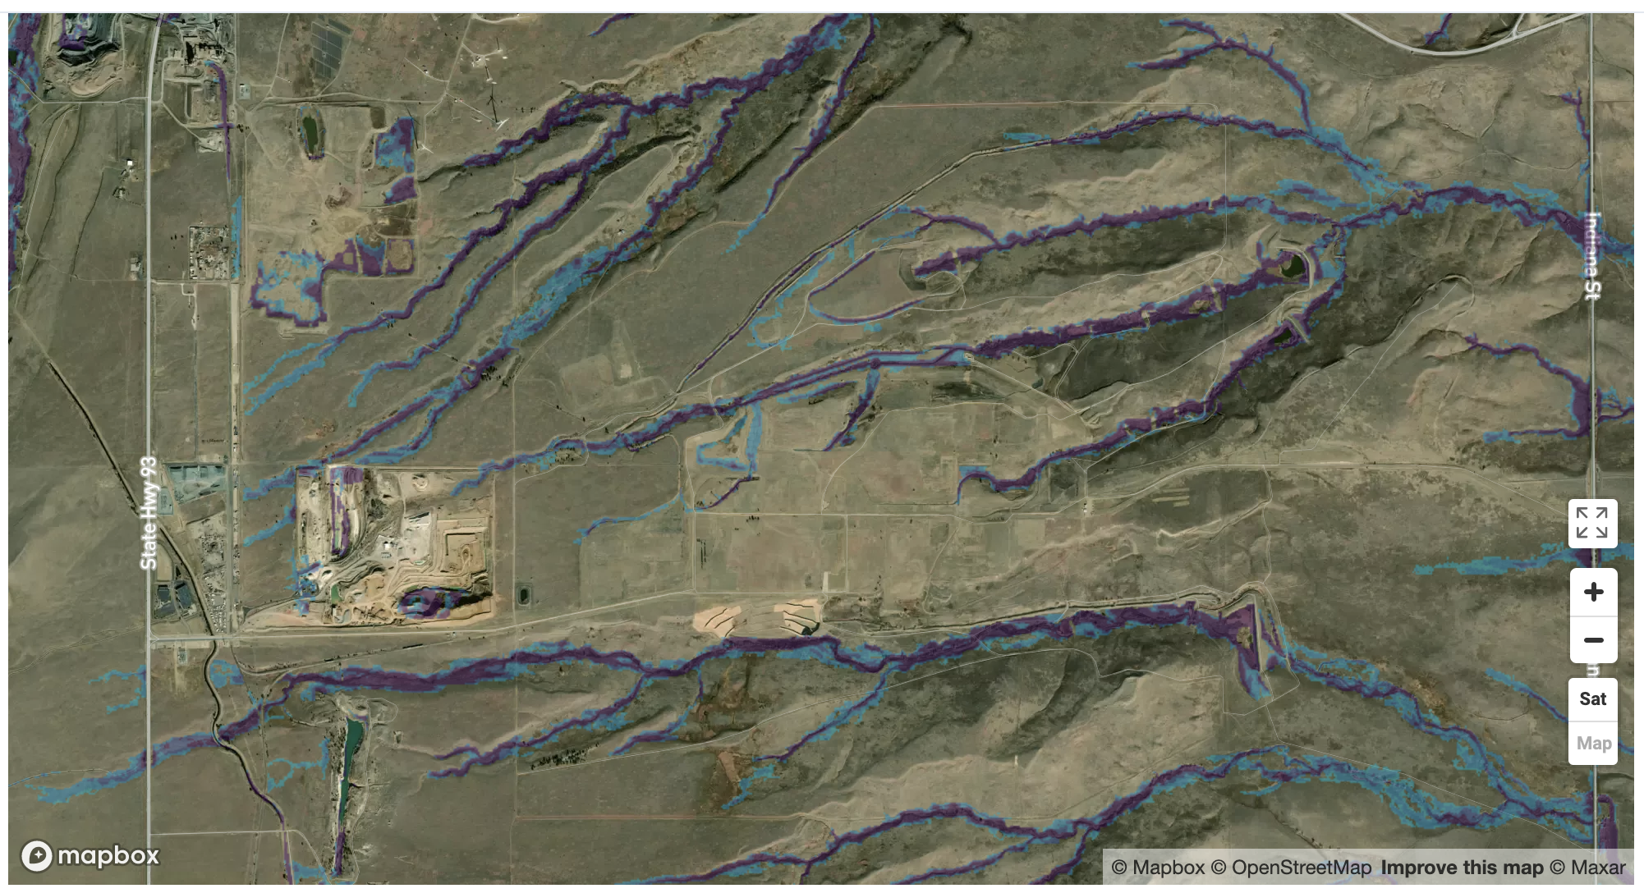

(a) (b)

Figure X3. Rocky Flats (CO): (a) the site boundary from the GEMS database and (b) the flooding extent from the First Street Foundation Flood Model.

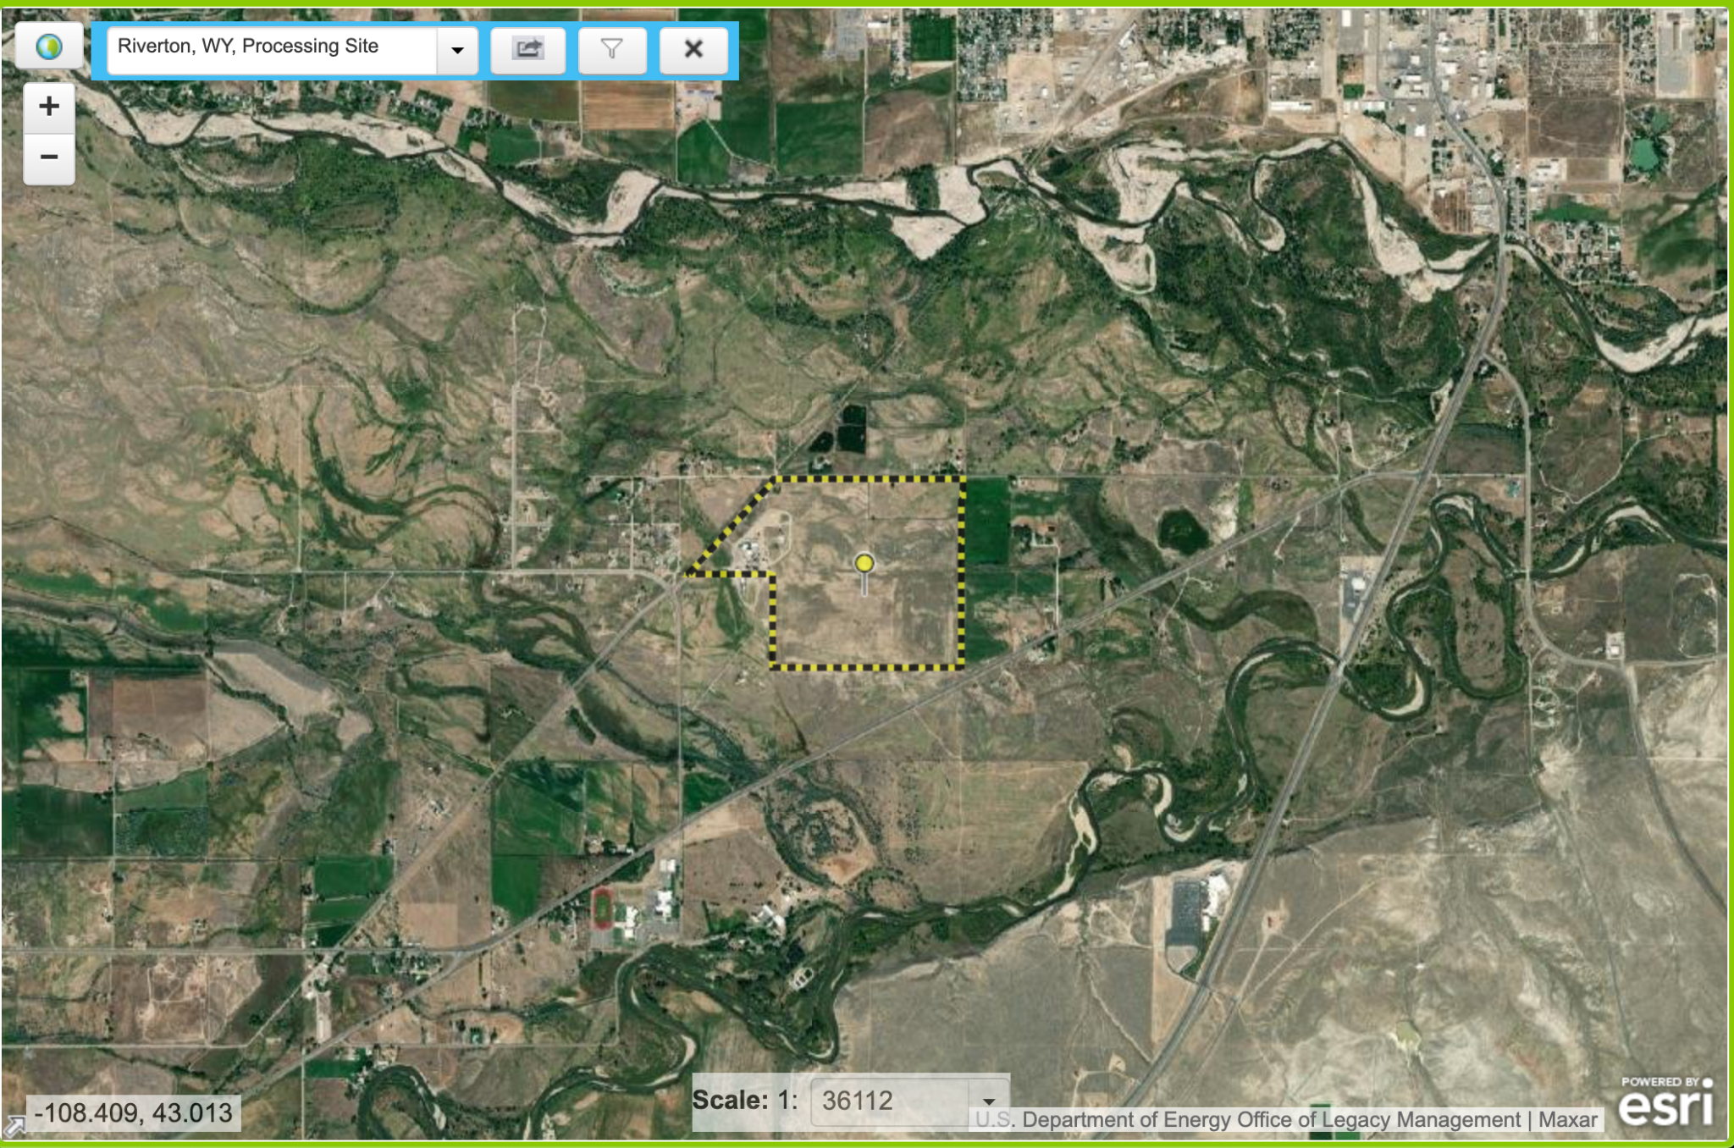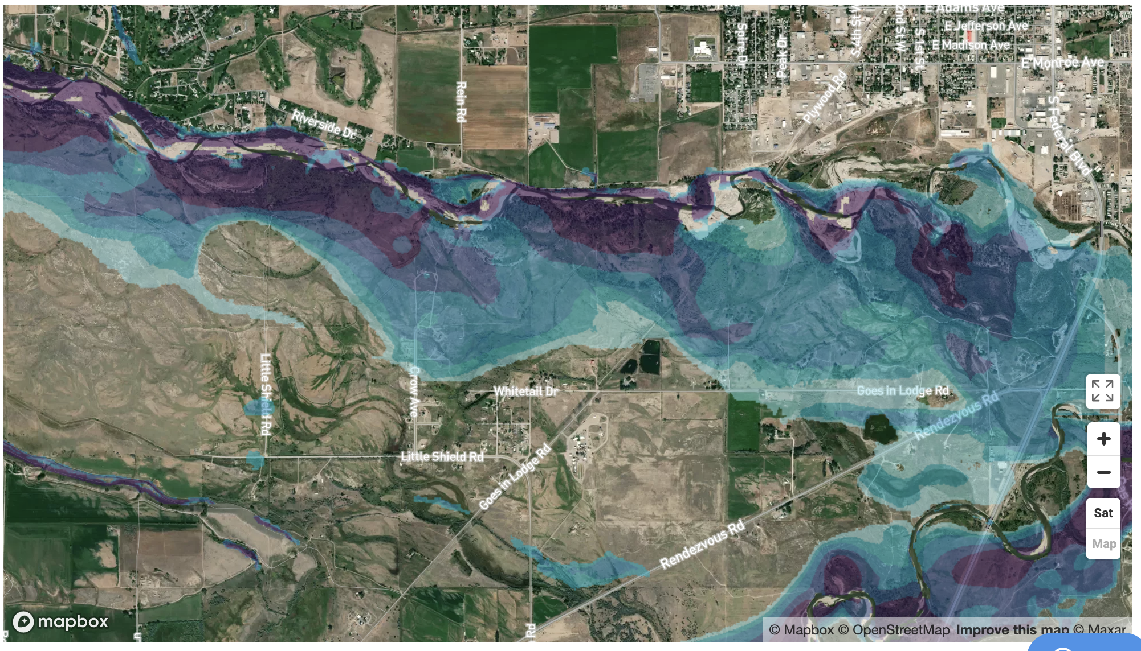

(a) (b)

Figure X4. Riverton (WY): (a) the site boundary from the GEMS database and (b) the flooding extent from the First Street Foundation Flood Model. I

Table 1. Flooding extents at the 19 LM sites. “Some area” means that the flooding extent overlaps with the site boundary, “Drainage” means that the flooding area is limited to the drainage area, and “None” means that there is no overlap between the flooding extent and the site boundary.

|  |  |  |
| --- | --- | --- |
| Name | Code | Flooding |
| L-Bar, NM, Disposal Site | BAR | Drainage |
| Bluewater, NM, Disposal Site | BLU | Some area |
| Burrell, PA, Disposal Site | BUR | Drainage |
| Canonsburg, PA, Disposal Site | CAN | Some area |
| Green River, UT, Disposal Site | GRN | None |
| Laboratory for Energy-Related Health Research, CA, Site | LEH | None |
| Lowman, ID, Disposal Site | LOW | None |
| Mound, OH, Site | MND | Drainage |
| Monticello, UT, Disposal and Processing Sites | MNT | Drainage |
| Monument Valley, AZ, Processing Site | MON | Drainage |
| Pinellas County, FL, Site | PIN | None |
| Parkersburg, WV, Disposal Site | PKB | None |
| Rifle, CO, Disposal/Processing Site | RFL | Some area |
| Rocky Flats, CO, Site | RFS | Drainage |
| Shirley Basin South, WY, Disposal Site | SBS | Drainage |
| Sherwood, WA, Disposal Site | SHE | Some area |
| Shiprock, NM, Disposal Site | SHP | None |
| Salt Lake City, UT, Disposal/Processing Site | SLP | None |
| Slick Rock, CO, Disposal/Processing Site | SRD | Drainage |

References:

Brown, J. T. (2016). Introduction to FEMA's National Flood Insurance Program (NFIP). Washington: Congressional Research Service.

Darabi, H., Choubin, B., Rahmati, O., Haghighi, A. T., Pradhan, B., & Kløve, B. (2019). Urban flood risk mapping using the GARP and QUEST models: A comparative study of machine learning techniques. Journal of hydrology, 569, 142-154.

Maidment, D. R. (2009). FEMA flood map accuracy. In World Environmental and Water Resources Congress 2009: Great Rivers (pp. 1-10).

Mignot, E., Li, X., & Dewals, B. (2019). Experimental modelling of urban flooding: A review. Journal of Hydrology, 568, 334-342.

Morrissey, W. A. (2006, February). FEMA's Flood Hazard Map Modernization Initiative. Congressional Research Service, The Library of Congress.

Neal, J., Schumann, G., & Bates, P. (2012). A subgrid channel model for simulating river hydraulics and floodplain inundation over large and data sparse areas. Water Resources Research, 48(11).

Sampson, C. C., Smith, A. M., Bates, P. D., Neal, J. C., Alfieri, L., & Freer, J. E. (2015). A high‐resolution global flood hazard model. *Water resources research*, *51*(9), 7358-7381.

Smith, L. C. (1997). Satellite remote sensing of river inundation area, stage, and discharge: A review. Hydrological processes, 11(10), 1427-1439.

Teng, J., Jakeman, A. J., Vaze, J., Croke, B. F., Dutta, D., & Kim, S. J. E. M. (2017). Flood inundation modelling: A review of methods, recent advances and uncertainty analysis. Environmental modelling & software, 90, 201-216.

Wing, O. E., Bates, P. D., Sampson, C. C., Smith, A. M., Johnson, K. A., & Erickson, T. A. (2017). Validation of a 30 m resolution flood hazard model of the conterminous United States. Water Resources Research, 53(9), 7968-7986.

Appendix X1. The site boundary and flooding extent

(The site names are shown in the fist figure for each site)

